TI 23 – 14. Technology Example – Baker Hughes XSight
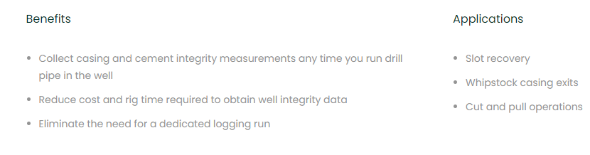
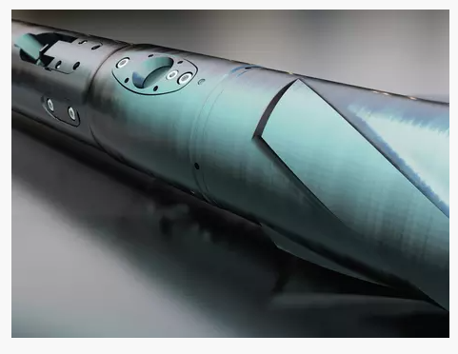
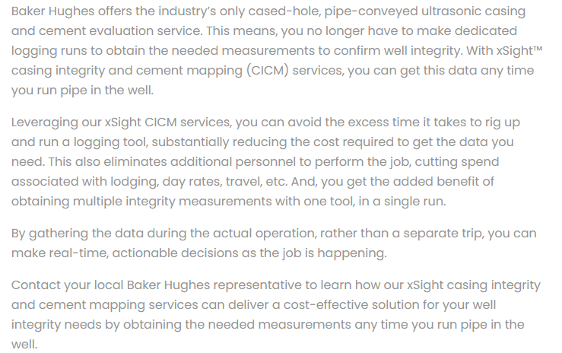
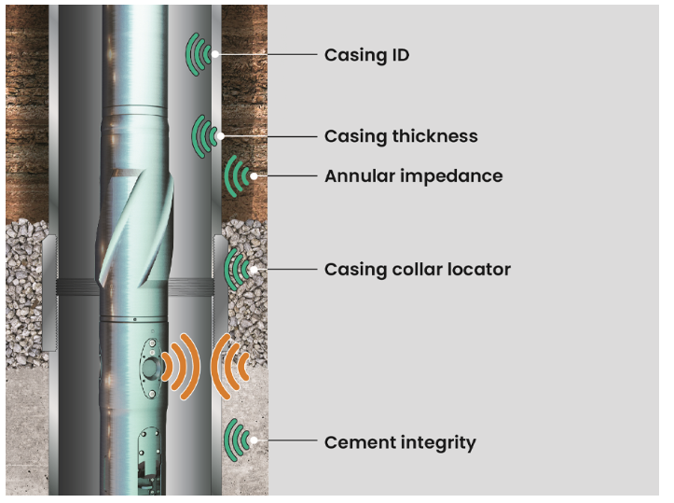

This is an example of this technology, vendors website link is below for further information.
Link: xSight casing integrity and cement mapping services | Baker Hughes

